

**Candidate Information Pack**

**High Needs Support Assistant**

*28.75 hours per week, Point 3 FTE £24,027 (actual salary- £16,312)*

**Waddington All Saints Academy, Lincoln**



**Contents**

|  |  |
| --- | --- |
| About the Trust | 1 |
| About us | 2 |
| Working at Waddington All Saints Academy | 4 |
| Benefits of being part of L.E.A.D. Academy Trust | 7 |
| How to apply | 10 |
| Job description and Person specification | 11 |

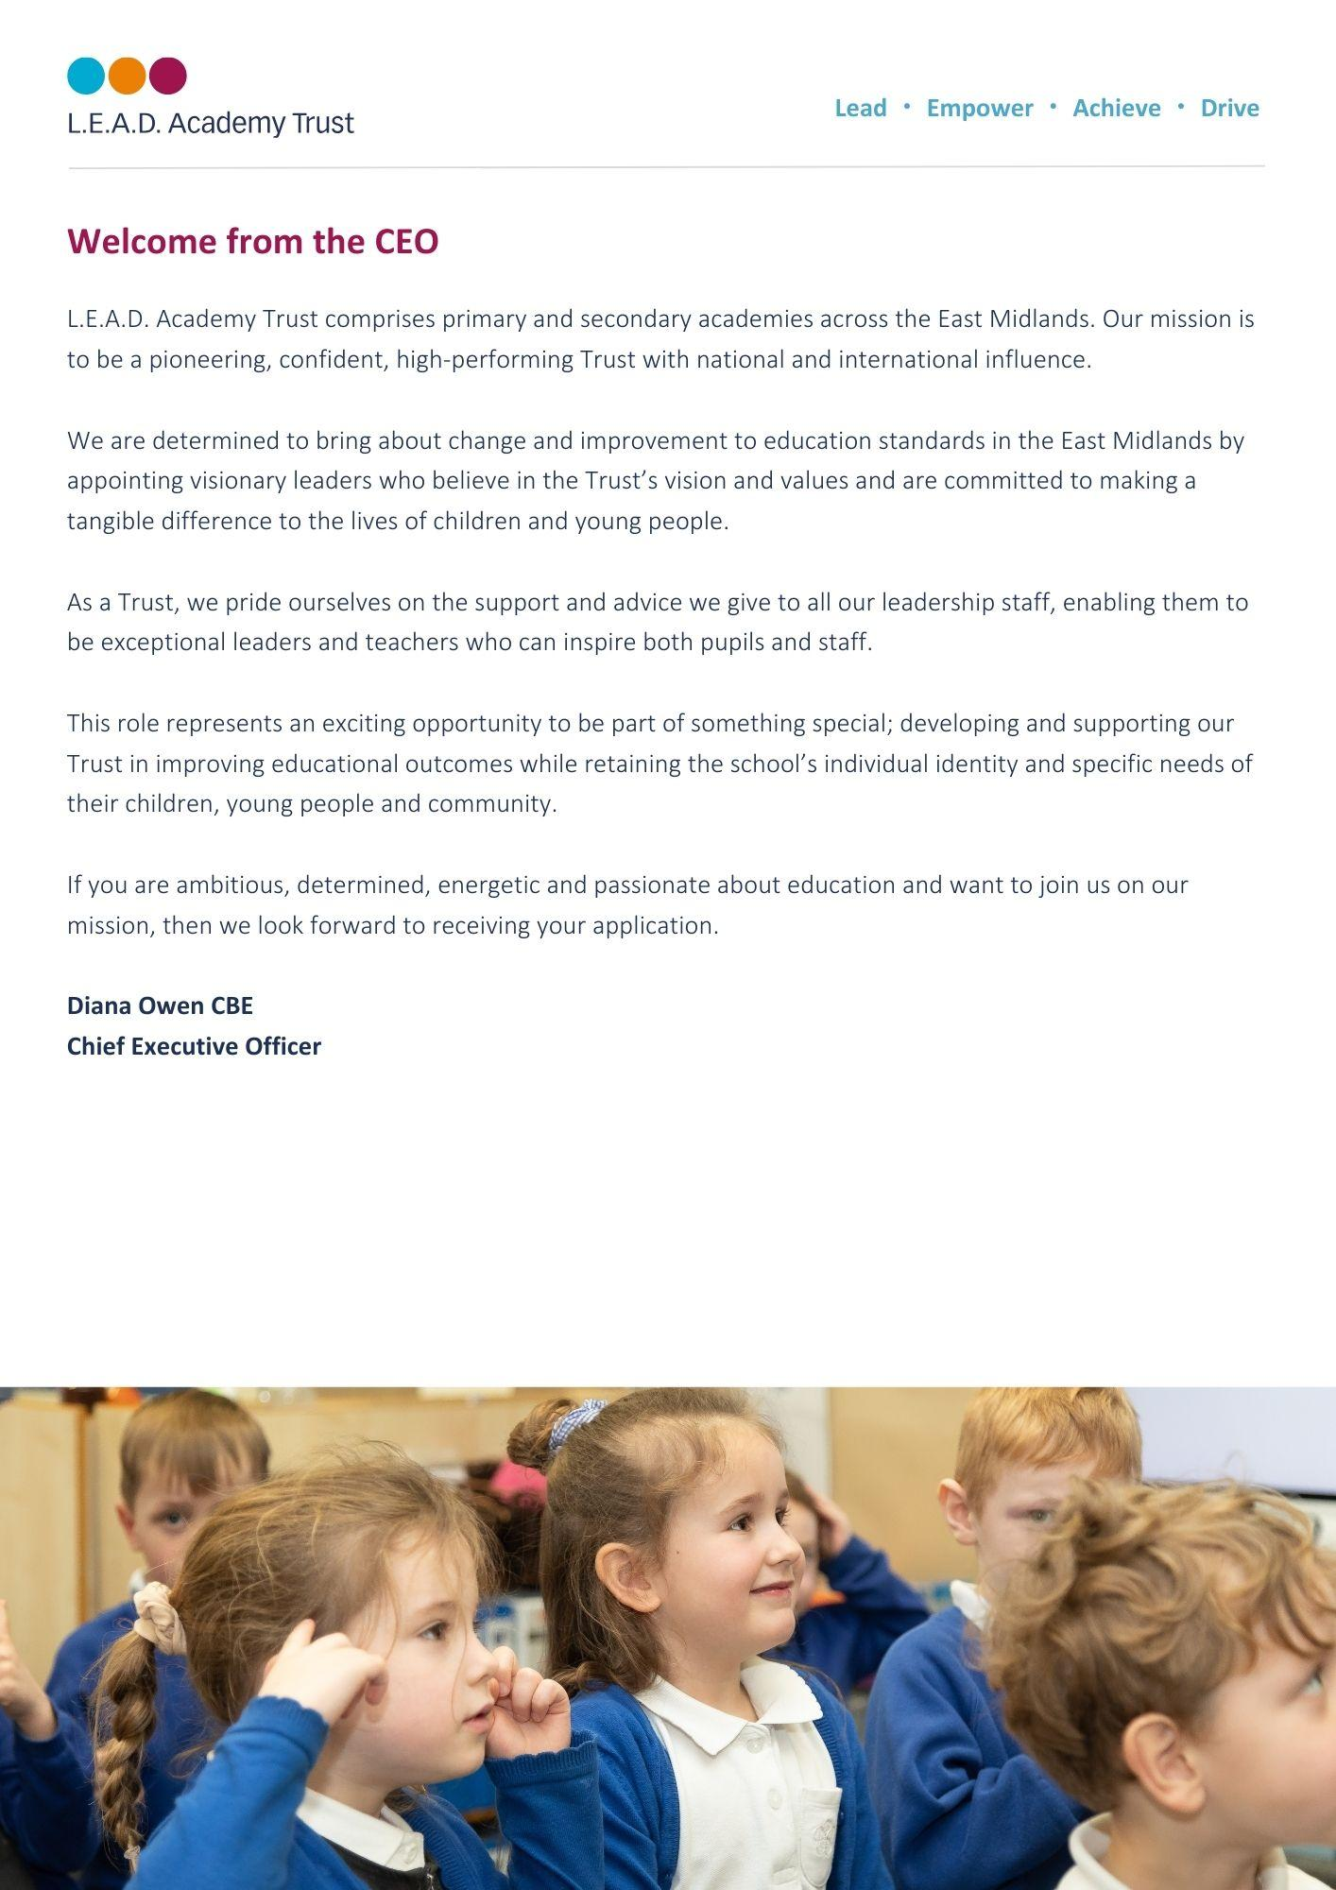

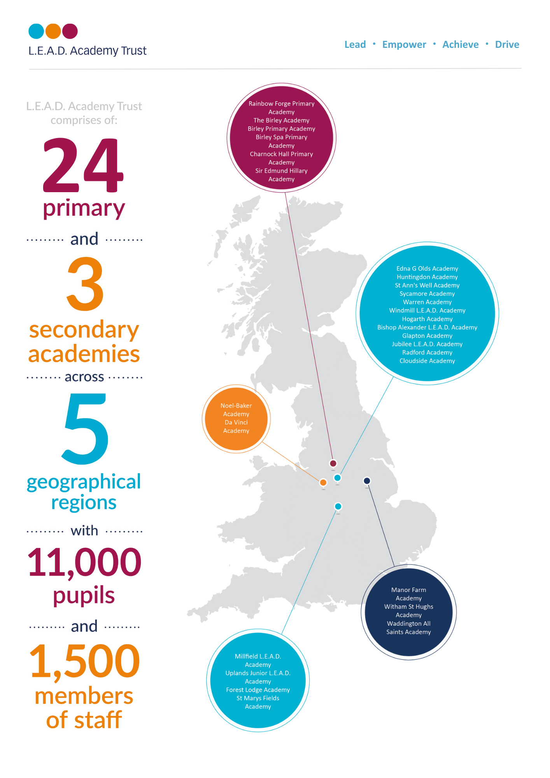

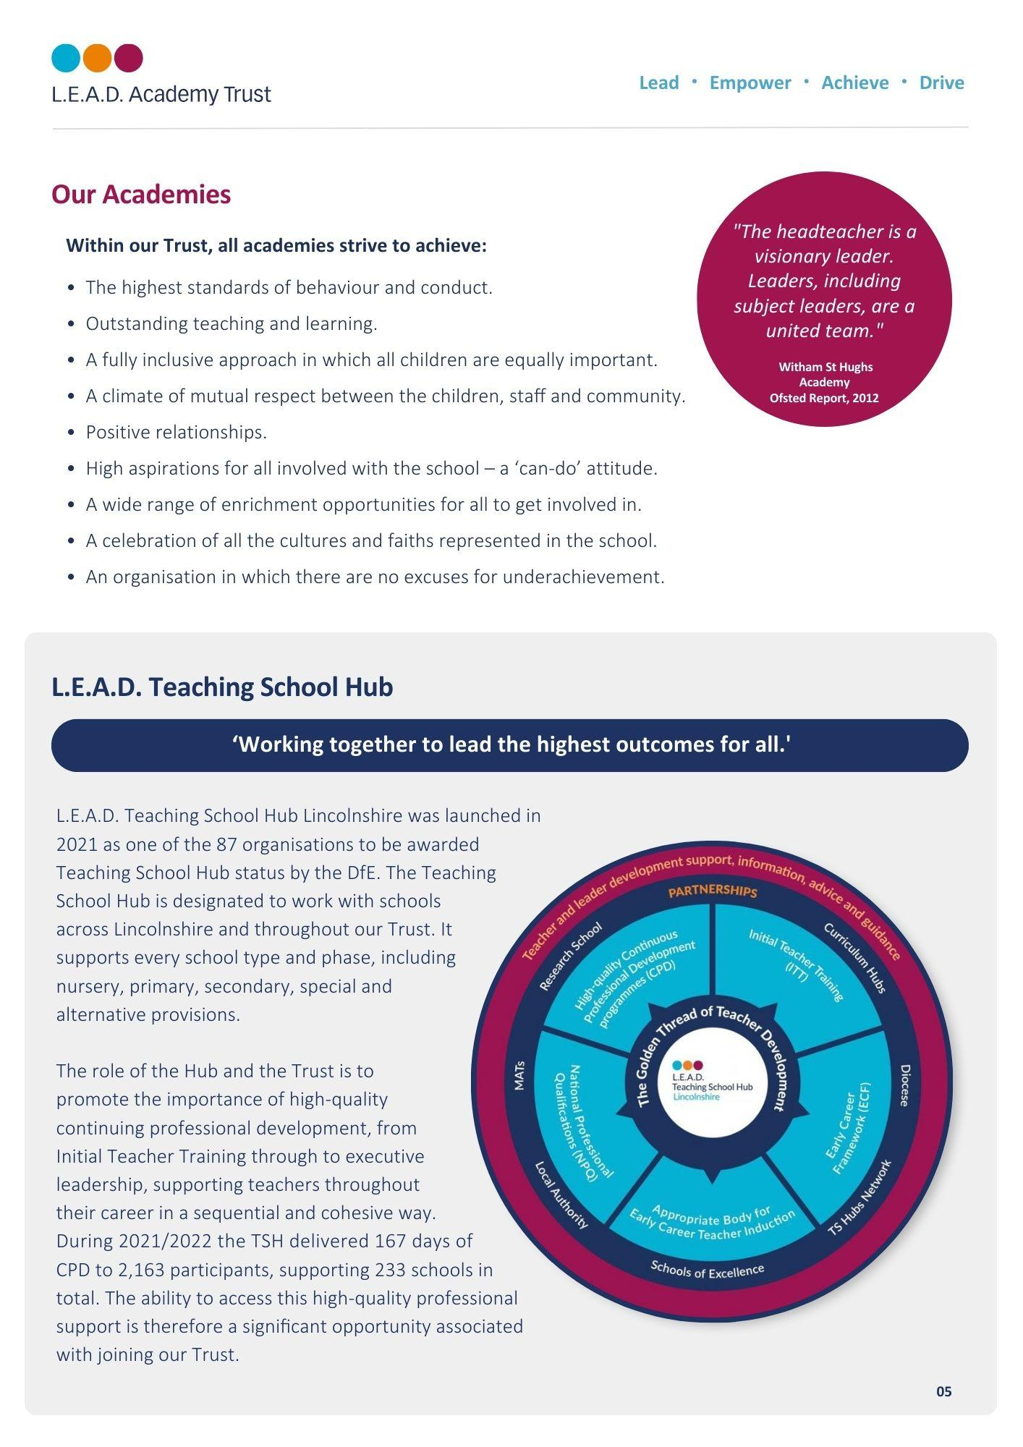

 **A message from the Headteacher (Zoe Jepson)**

“If they have wings, why make them walk?”

At Waddington All Saints Academy we aim to provide an exceptional learning environment and experience that enables children to thrive and develop as learners and leaders.

We want to inspire and motivate all children to have a wonderful desire to learn and grow as individuals and as a collective. To empower and support them to become life-long learners who are prepared to take risks, learn with growing independence and develop skills that enable them to fly high academically, socially, emotionally and physically.

Through the delivery of irresistible learning opportunities and rich experience, we strive to give children the ability and confidence to work and speak as experts; progressively building transferable knowledge and understanding that is memorable, broad and empowering. This, alongside the relentless drive for high quality outcomes and progress, underpinned by excellence and pride, exemplifies our ambition for our pupils.

We expect pupils to behave as role models and good citizens and support them to understand the choices and behaviours that will enable them to make positive decisions. We do this within a culture of mutual respect for all within our community, encouraging kindness, tolerance and care for others.

We measure our success in our ability to support pupils to have the skills, knowledge, personal qualities and drive to be successful within the next stages of their life and beyond and to make a positive contribution to life in modern Britain.

Zoe Jepson

Headteacher

**Our community**

The academy serves a wonderful community made up of a busy village on a main route into Lincoln and a significantly important RAF base. The school was formed as a primary school in 1987, amalgamating St Clements Junior School, on the site of the present school, and St Michael’s County Infant School. To overcome disagreement at the time about which name should be given to the new school, it was renamed ‘All Saints’.

The behaviour and attitude of the children of All Saints is excellent. It is an inclusive and welcoming place to be, making it easy for new pupils and staff to feel welcome and settle quickly.

**Developing staff, developing leaders**

Learning and success is at the heart of our culture, so we invest in the development of our staff as learners and developing leaders. There is a rich programme of CPD which include leadership opportunities, in house training, National College courses and working with the L.E.A.D. Teaching School Hub.

As a Teaching Assistant, within the Trust, you also have access to high quality professional development and a wealth of support, including from the Senior Leadership Team and the Headteacher.

The academy is fortunate to have a strong and supportive governing body, who share our commitment to further strengthen teaching and learning and ensure that all children reach their full potential.

Applications are invited from those who have experience of working within early years and Key Stage 1 and we would encourage you to visit the school to meet our children and staff.

**Our values**

To always try to be:

* Respectful, tolerant and kind
* Resilient and determined to succeed
* Positive and enthusiastic
* Responsible, caring and safe
* A good role model and a team player.

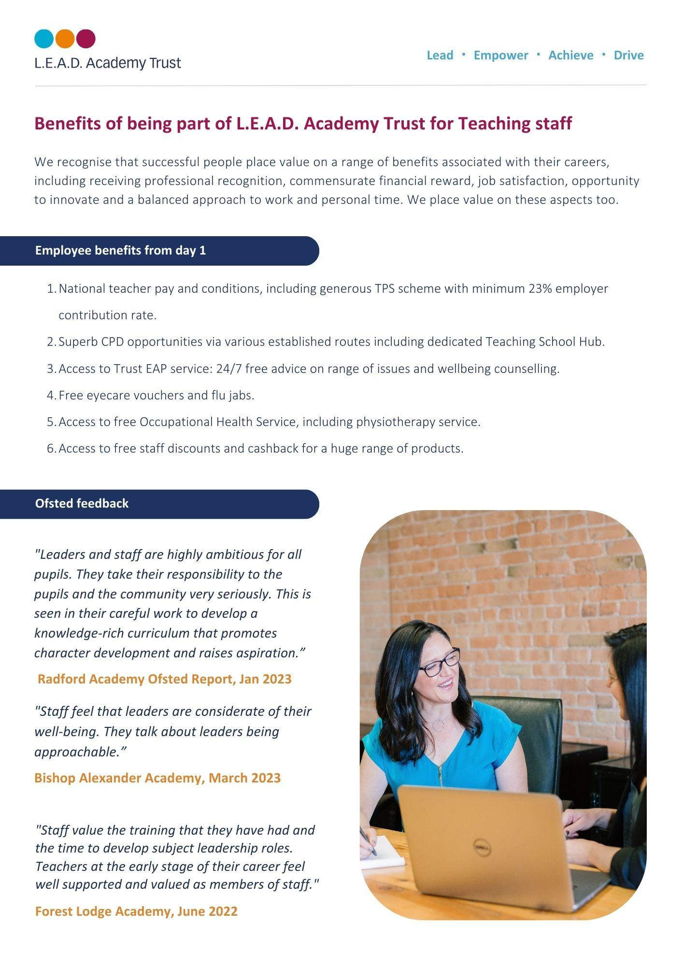

***“The behaviour of pupils is outstanding. Pupils follow school routines to the letter. As a result, behaviour in the school grounds, in corridors and in the dining hall is usually impeccable.”***

OFSTED 2014

**How to apply**

Please send a completed application form and covering letter explaining your interest in the role and how you meet the person specification to: office@waddingtonallsaintsacademy.co.uk

**CLOSING DATE**: **8am on Friday 4th October**

**INTERVIEWS**: We expect interviews to take place **on Monday 7th October**

**Candidate visiting dates:** In order to arrange a visit to Waddington All Saints, please call 01522 820099.

Applications will be reviewed upon receipt, therefore shortlisted candidates may be contacted in advance of the closing date.

L.E.A.D. Academy Trust is committed to safeguarding and promoting the welfare of children and young people and we can expect all staff and volunteers to share this commitment. This post is subject to an enhanced DBS check.

For an informal, confidential discussion about this opportunity, please email: **office@waddingtonallsaintsacademy.co.uk**

  
  
  
  
  
  
  
  
  
  
  
  
  
  
  
  
  
  
  
  
  


**Job description**

**Key responsibilities and accountabilities**

**Job Title:** Teaching Assistant 1

**Pay Scale:** NJC 2 – 7

**Location:** Waddington All Saints Academy

**Line Manager:** Deputy Head/SENDCO

**Job purpose:**

* To work with children as part of a team under the overall direction of the Headteacher who will be responsible for the policy and educational programme and for matters of control and discipline within the National Curriculum Framework.
* To assist the class teacher in maximising the participation of pupils in the social and academic processes of the school.
* Under the instruction/guidance of teaching/senior staff, to encourage pupils to become more independent learners and help to raise the standard of achievement for all pupils.
* All activities undertaken by colleagues at this level would be closely monitored by the class teacher or more senior colleagues and the content of learning activities would always be planned by the teacher/more senior staff.

D**uties and Responsibilities:**

**Key Duties**

* Support pupils’ learning activities including additional learning needs and development and maintain an awareness of the planning, delivery and evaluation of learning activities.
* Establish and maintain relationships with individual pupils and groups by using effective communication and understanding the value of treating all individuals fairly.
* Contribute to the management of pupil behaviour by encouraging positive behaviour in the classroom.

**Support for the Pupil**

* Help with the care and support of pupils by supporting children’s communication and intellectual development and physical, emotional and social development. To contribute to the planning to meet children’s development needs.
* Contribute to the health and well-being of pupils through the support of safeguarding for pupils by ensuring a safe environment, and following policies & procedures at all times.
* Assist with the personal and intimate care of pupils.
* To support children and young people with SEND, supporting them to actively participate in learning activities. To liaise with parent/carers/outside agencies as required.

**Support for the Teacher**

* Help with classroom resources and records by maintaining confidentiality of information at all times and ensuring resources are in place for when they are required.
* Contribute to the management of pupil behaviour by encouraging positive behaviour in the classroom, referring to senior colleagues as appropriate.
* Escort and assist pupils on educational visits and out of school activities.

**Support for the Curriculum**

* Support the school curriculum including literacy and numeracy activities by using strategies and techniques for promoting learning.
* Provide support for learning activities within the teaching and learning programme, monitoring the effectiveness of activities in promoting pupils’ learning and modifying these where necessary.
* Support pupils to use ICT materials and resources effectively to advance their learning.

**Support for the School**

* Maintain effective working relationships with colleagues and parents through effective communication and providing support for pupils, colleagues and parents as required.
* Willingness to keep up to date with professional practice by maintaining an up-to-date understanding of the requirements of the role and individual responsibilities.

**Influencing and Managing Relationships:**

• Headteacher

• L.E.A.D. Central Support

• External agencies

• Parents and carers

• Governors

• Senior Leadership Team

• Staff

As job descriptions cannot be exhaustive, the post-holder may be required to undertake other duties which are broadly in line with above key responsibilities.

At L.E.A.D we have a strong vision and four core principles, to lead, empower, achieve and drive, which you will be expected to demonstrate in your working practices.

**Person specification**

**Person Specification**

The person specification listed below outlines the competences, knowledge and behaviour of candidates who would be suitable for this role. The two right-hand columns provide guidance as to whether these items are essential (E) or desirable (D) criteria.

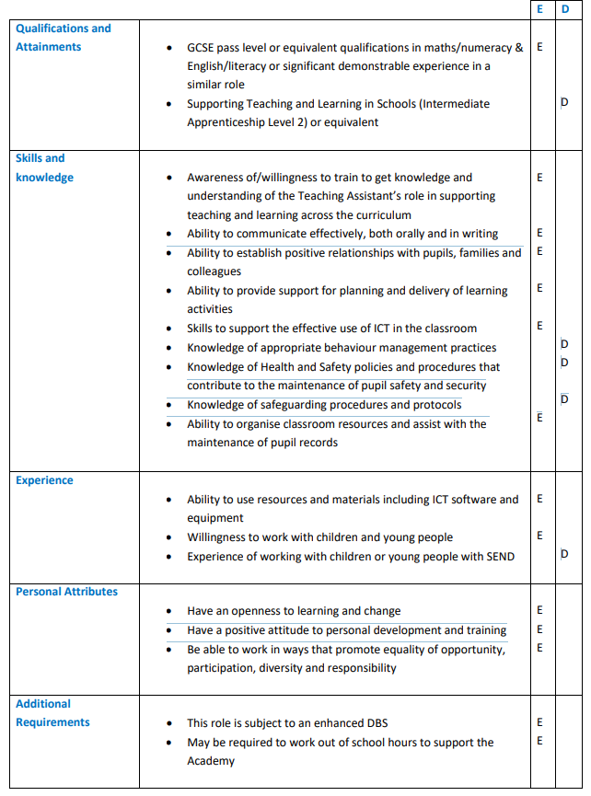



**Email address:**

office@waddingtonallsaintsacademy.co.uk

**Phone number:**

01522 820099