

**Candidate Information Pack**

**Class Teacher- Year 2**

***To start: January 2025 or an Easter start would be considered for the right candidate.***

**Waddington All Saints Academy, Lincoln**



**Contents**

|  |  |
| --- | --- |
| About the Trust | 1 |
| About us | 2 |
| Working at Waddington All Saints Academy | 4 |
| Benefits of being part of L.E.A.D. Academy Trust | 7 |
| How to apply | 10 |
| Job description and Person specification | 11 |

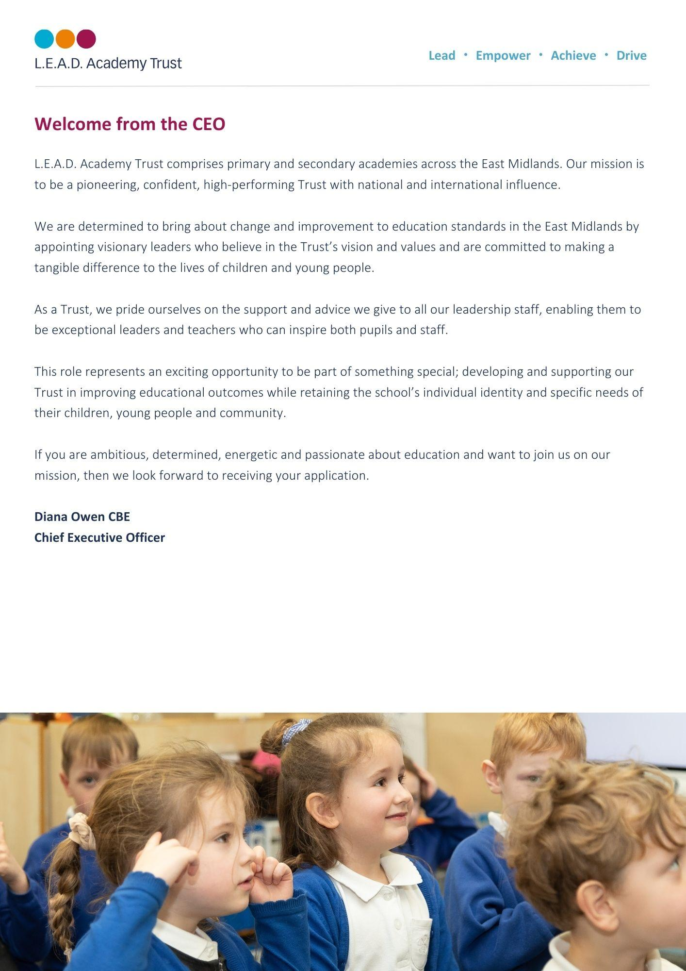

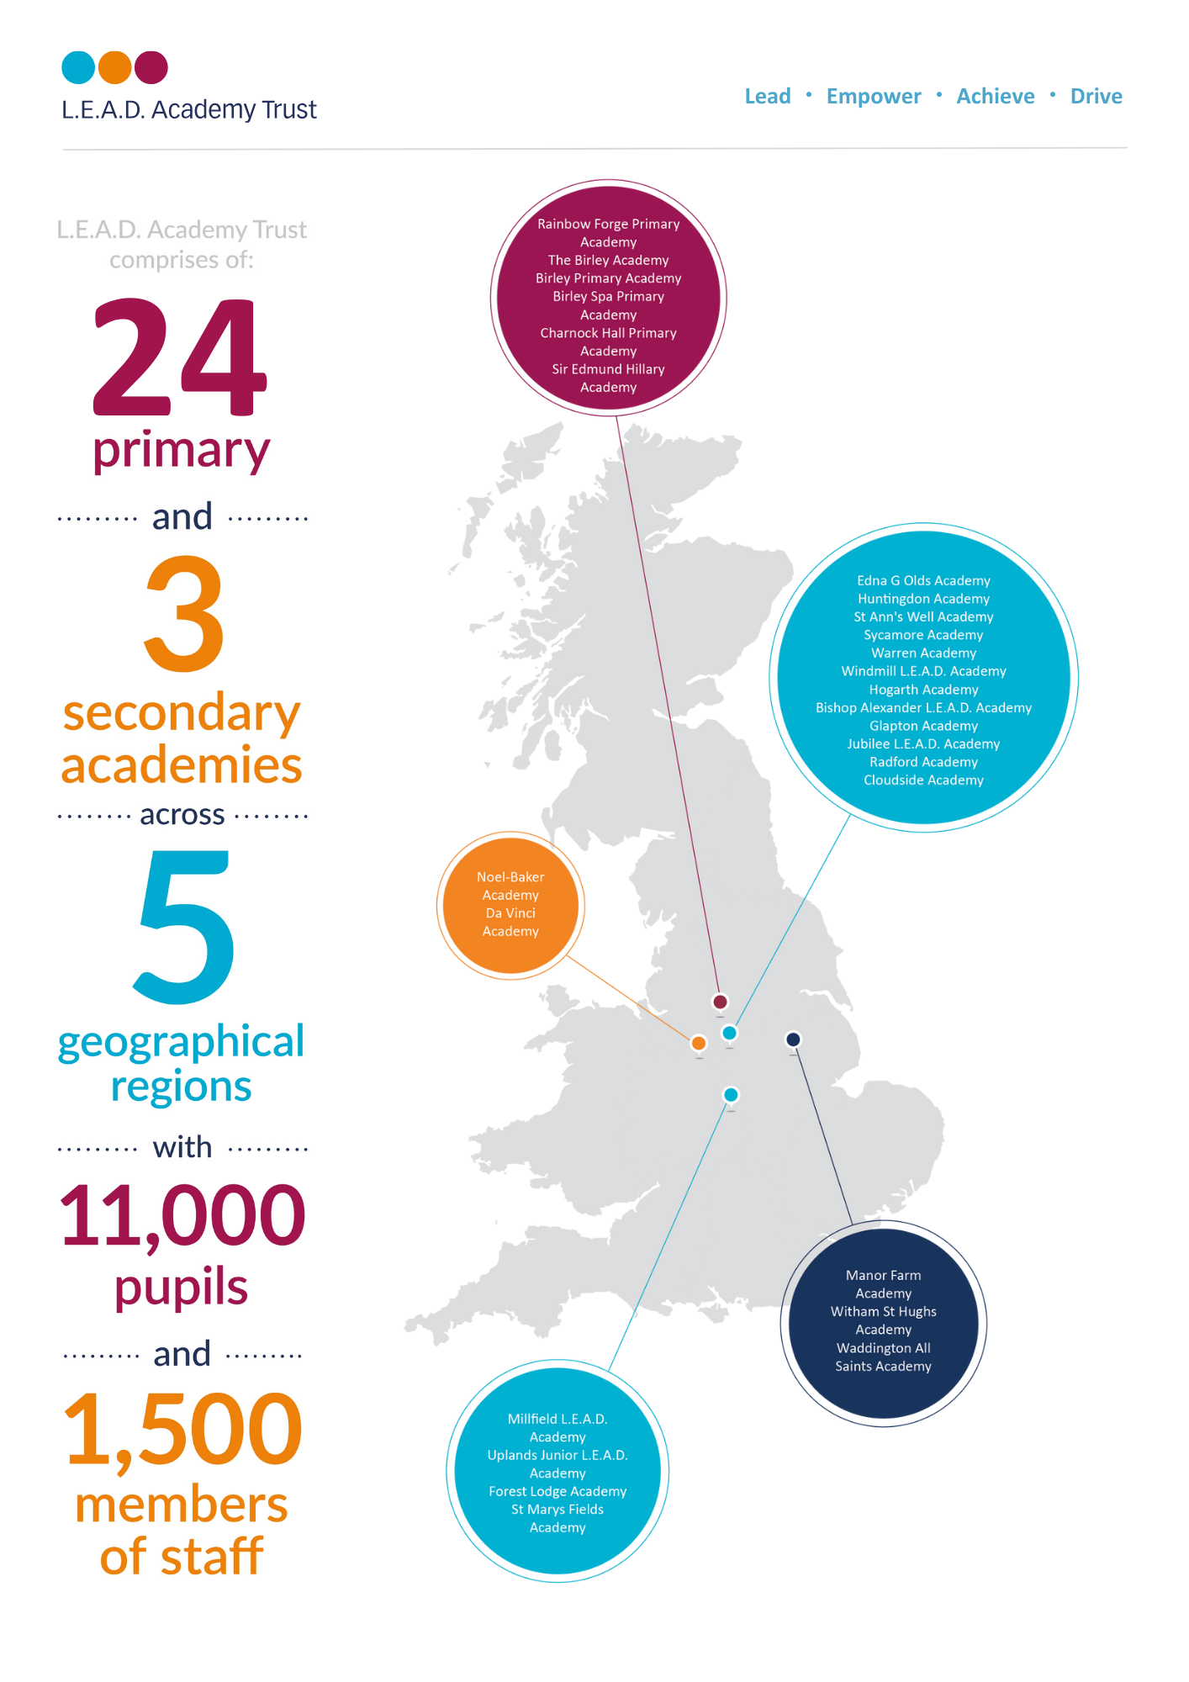

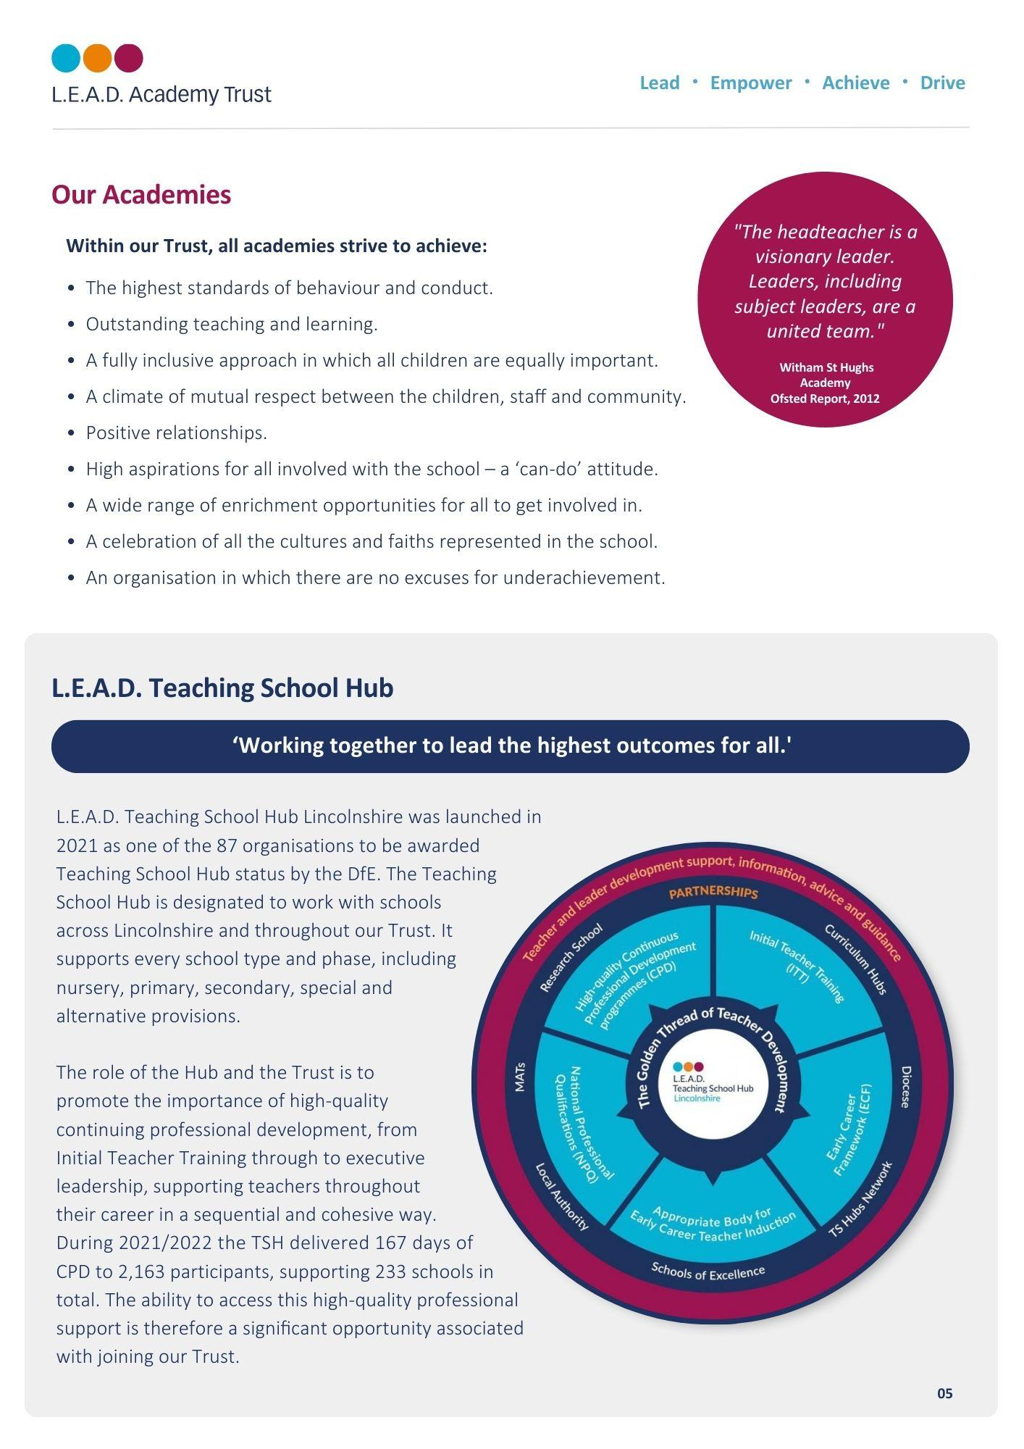

 **A message from the Headteacher (Zoe Jepson)**

“If they have wings, why make them walk?”

At Waddington All Saints Academy we aim to provide an exceptional learning environment and experience that enables children to thrive and develop as learners and leaders.

We want to inspire and motivate all children to have a wonderful desire to learn and grow as individuals and as a collective. To empower and support them to become life-long learners who are prepared to take risks, learn with growing independence and develop skills that enable them to fly high academically, socially, emotionally and physically.

Through the delivery of irresistible learning opportunities and rich experiences, we strive to give children the ability and confidence to work and speak as experts; progressively building transferable knowledge and understanding that is memorable, broad and empowering. This, alongside the relentless drive for high quality outcomes and progress, underpinned by excellence and pride, exemplifies our ambition for our pupils.

We expect pupils to behave as role models and good citizens and support them to understand the choices and behaviours that will enable them to make positive decisions. We do this within a culture of mutual respect for all within our community, encouraging kindness, tolerance and care for others.

We measure our success in our ability to support pupils to have the skills, knowledge, personal qualities and drive to be successful within the next stages of their life and beyond and to make a positive contribution to life in modern Britain.

Zoe Jepson

Headteacher

**Our community**

The academy serves a wonderful community made up of a busy village on a main route into Lincoln and a significantly important RAF base. The school was formed as a primary school in 1987, amalgamating St Clements Junior School, on the site of the present school, and St Michael’s County Infant School. To overcome disagreement at the time about which name should be given to the new school, it was renamed ‘All Saints’.

The behaviour and attitude of the children of All Saints is excellent. It is an inclusive and welcoming place to be, making it easy for new pupils and staff to feel welcome and settle quickly.

**Developing staff, developing leaders**

Learning and success is at the heart of our culture, so we invest in the development of our staff as learners and developing leaders. There is a rich programme of CPD which include leadership opportunities, in house training, National College courses and working with the L.E.A.D. Teaching School Hub.

As a teacher, within the Trust, you also have access to high quality professional development and a wealth of support, including from the Senior Leadership Team and the Headteacher.

The academy is fortunate to have a strong and supportive governing body, who share our commitment to further strengthen teaching and learning and ensure that all children reach their full potential.

Applications are invited from those who have experience of working within Key Stage 1 and we would encourage you to visit the school to meet our children and staff.

**Our values**

To always try to be:

* Respectful, tolerant and kind
* Resilient and determined to succeed
* Positive and enthusiastic
* Responsible, caring and safe
* A good role model and a team player.

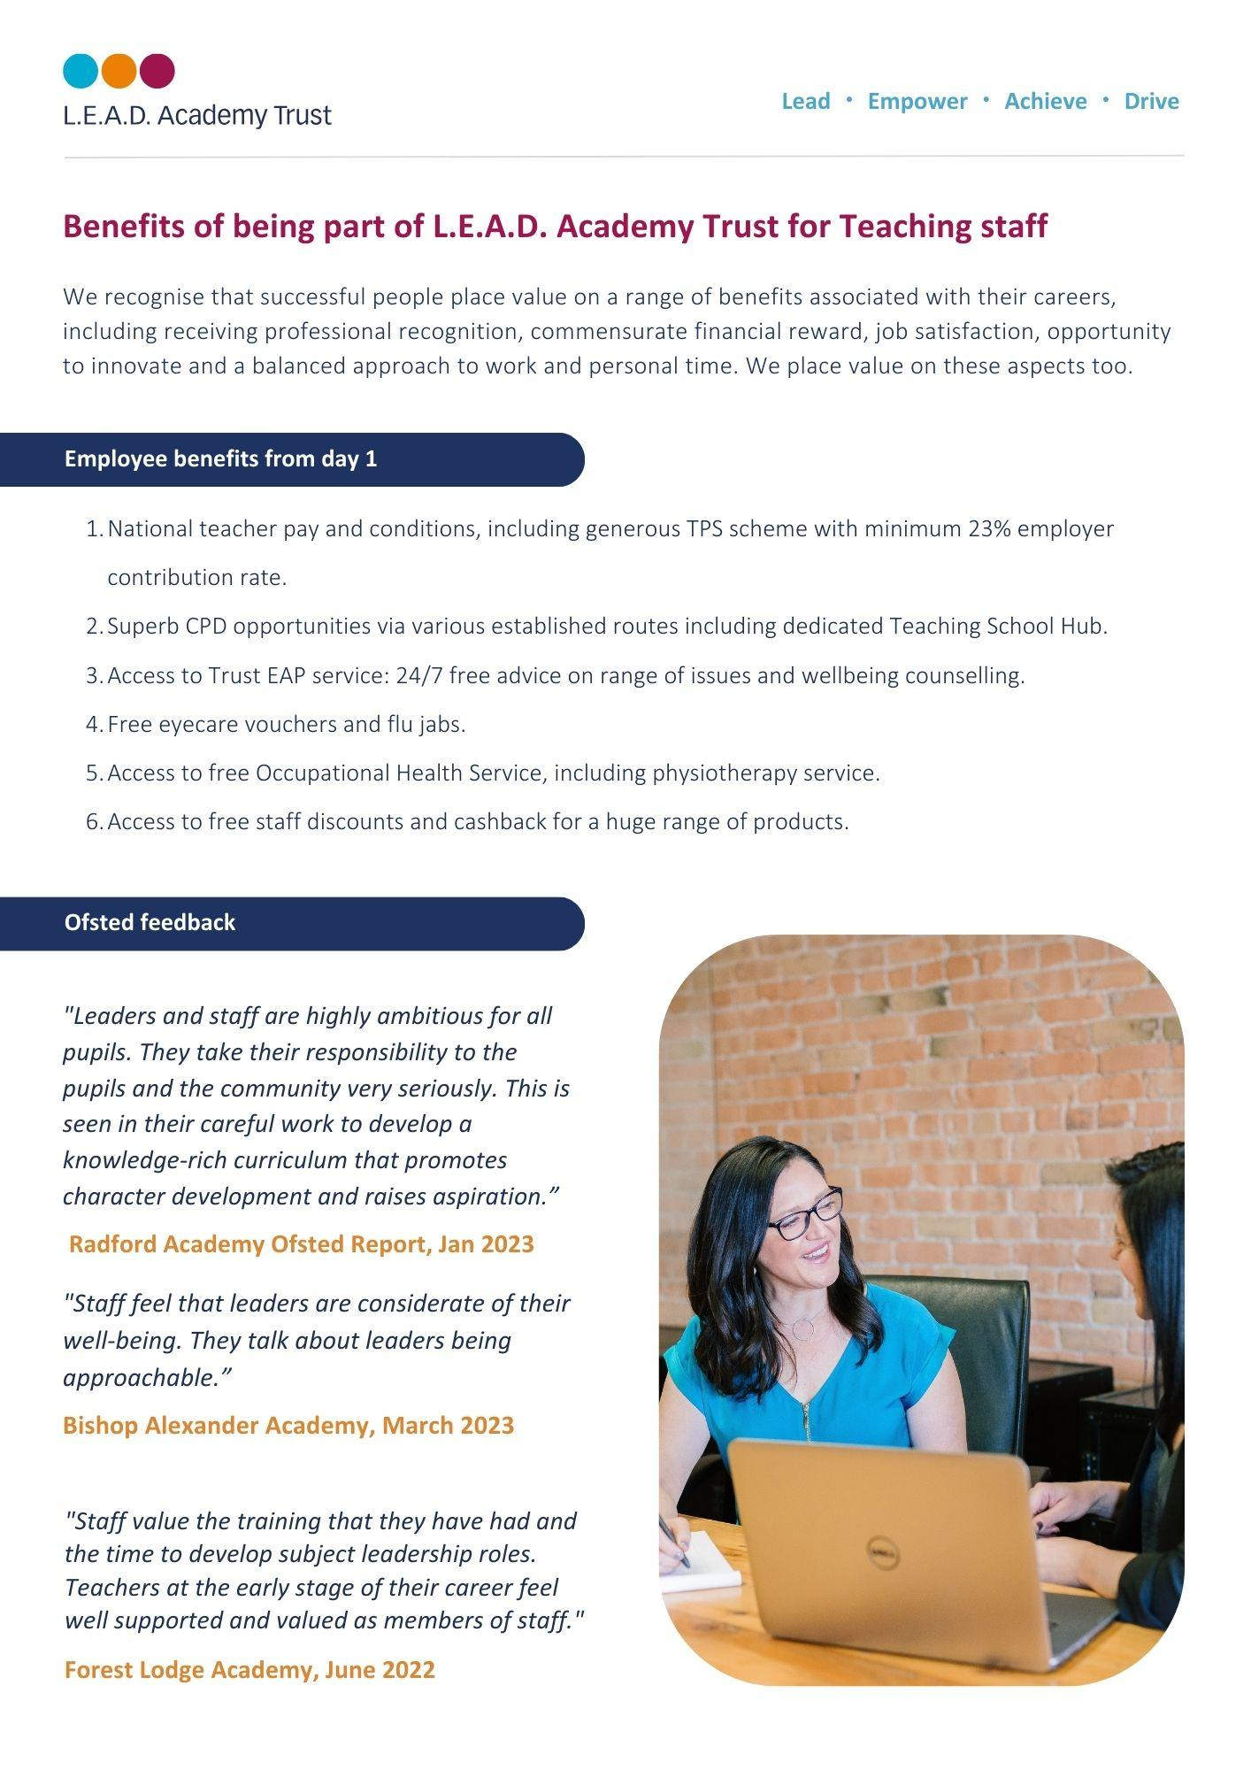

***“The behaviour of pupils is outstanding. Pupils follow school routines to the letter. As a result, behaviour in the school grounds, in corridors and in the dining hall is usually impeccable.”***

OFSTED 2014

**How to apply**

Please send a completed application form and covering letter explaining your interest in the role and how you meet the person specification to: office@waddingtonallsaintsacademy.co.uk

**CLOSING DATE**: **8am on Friday 29th November**

**INTERVIEWS**: We expect interviews to take place **on Wednesday 4th December**

**Candidate visiting dates: 20th November at 10am & 4pm**

**26th November at 4pm**

In order to arrange a visit to Waddington All Saints, please call 01522 820099.

Applications will be reviewed upon receipt, therefore shortlisted candidates may be contacted in advance of the closing date.

L.E.A.D. Academy Trust is committed to safeguarding and promoting the welfare of children and young people and we can expect all staff and volunteers to share this commitment. This post is subject to an enhanced DBS check.

For an informal, confidential discussion about this opportunity, please email: **office@waddingtonallsaintsacademy.co.uk**

  
  
  
  
  
  
  
  
  
  
  
  
  
  
  
  
  
  
  
  
 **Job description**

**Key responsibilities and accountabilities**

**Job role:** Teacher

**Salary:** MPS (This post is suitable for an ECT)

**Line Manager:** The Headteacher

**We are looking to appoint a teacher to work within our Key Stage 1 Team, in Year 2.**

**Teaching**

50.2. Plan and teach lessons to the classes they are assigned to teach within the context of the school’s plans, curriculum and schemes of work.

50.3. Assess, monitor, record and report on the learning needs, progress and achievements of assigned pupils.

50.4. Participate in arrangements for preparing pupils for external examinations.

**Whole school organisation, strategy and development**

50.5. Contribute to the development, implementation and evaluation of the school’s policies, practices and procedures in such a way as to support the school’s values and vision.

50.6. Work with others on curriculum and/or pupil development to secure co-ordinated outcomes.

50.7. Subject to paragraph 52.7 supervise and so far as practicable teach any pupils where the person timetabled to take the class is not available to do so.

**Health, safety and discipline**

50.8. Promote the safety and well-being of pupils.

50.9. Maintain good order and discipline among pupils.

**Management of staff and resources**

50.10.Direct and supervise support staff assigned to them and, where appropriate, other teachers.

50.11.Contribute to the recruitment, selection, appointment and professional development of other teachers and support staff.

50.12.Deploy resources delegated to them

**Job purpose:**

* To exemplify excellent classroom practice that results in high standards of learning and achievement for the pupils/students in your care.
* To support the Senior Leadership Team in establishing a culture that promotes excellence, equality and high expectations of all pupils/students and the L.E.A.D. Trust values.
* To ensure that your professional practice is informed by rigorous self-evaluation and that it continuously improves learning and pastoral outcomes.
* To ensure that you provide a safe and happy environment that promotes the welfare of children.
* To ensure all safeguarding and child protection policies are adhered to fully and without reservation in line with statutory duties.

**Duties and Responsibilities:**

**Teaching and learning**

* Set high expectations for all pupils/students which inspire, motivate and challenge pupils/students.
* Establish a safe and stimulating environment for pupils/students, rooted in mutual respect.
* Set goals that stretch and challenge pupils/students of all backgrounds, abilities and dispositions.
* Demonstrate consistently the positive attitudes, values and behaviour which are expected of pupils/students.
* Promote excellent learning behaviours in the pupils/students so that they work hard in the academy and in completing tasks set for homework.

**Promote good progress and outcomes**

* Be accountable for all pupils/students’ attainment, progress and outcomes assigned to them.
* Be aware of pupils/students’ capabilities and their prior knowledge, and plan teaching to build on these.
* Guide pupils/students to reflect on the progress they have made and their emerging needs.
* Demonstrate knowledge and understanding of how children learn and how this impacts on the organisation of the classroom and teaching.
* Encourage pupils to take a responsible and conscientious attitude to their own work and study.
* Encourage pupils/students to develop study skills in order to learn more effectively and with increasing independence.

**Demonstrate good subject and curriculum knowledge**

* Have a secure knowledge of the relevant subjects and curriculum areas taught, foster and maintain pupils/students’ interest in the subject, and address misunderstandings.
* Demonstrate a critical understanding of developments in the subjects and curriculum areas, and promote the value of scholarship.
* Demonstrate an understanding of and take responsibility for promoting high standards of literacy, articulacy and the correct use of standard English in all work produced.
* If teaching early reading, demonstrate a clear understanding of systematic synthetic phonics.
* If teaching early mathematics, demonstrate a clear understanding of appropriate teaching strategies.

**Plan and teach well-structured lessons**

* Impart knowledge and develop understanding through effective use of lesson time.
* Promote a love of learning and children’s intellectual curiosity.
* Set homework and plan other out-of-class activities to consolidate and extend the knowledge and understanding pupils have acquired.
* Reflect systematically on the effectiveness of lessons and approaches to teaching.
* Contribute to the design and provision of an engaging curriculum within the relevant subject area(s).

**Adapt teaching to respond to the strengths and needs of all pupils/students**

* Know when and how to differentiate appropriately.
* Understand how a range of factors can inhibit pupils/students’ ability to learn, apply this understanding to overcome these restrictions to learning.
* Demonstrate an awareness of the physical, social and intellectual development of children, and know how to adapt teaching to support pupils/students’ education at different stages.
* Have a clear understanding of the needs of all pupils/students, including those with special educational needs; those of high ability; those with English as an additional language; those with disabilities; and be able to use and evaluate distinctive teaching approaches to engage and support them.

**Make accurate and productive use of assessment**

* Know and understand how to assess the relevant subject and curriculum areas, including statutory assessment requirements.
* Make use of formative and summative assessment to secure pupils/students’ progress.
* Use relevant data to monitor progress, set targets, and plan subsequent lessons.
* Give pupils/students regular feedback, both orally and through accurate marking, and encourage pupils/students to respond to the feedback.

**Behaviour and safety and Personal Development**

* Manage behaviour effectively to ensure a purposeful, stimulating and safe learning environment.
* Have clear rules and routines for behaviour in classrooms, and take responsibility for promoting good and courteous behaviour both in classrooms and around the site, in accordance with the academy’s behaviour policy.
* Have high expectations of behaviour, and establish a framework for discipline with a range of strategies, using praise, sanctions and rewards consistently and fairly.
* Manage classes effectively, using approaches which are appropriate to pupils/students’ needs in order to involve and motivate them.
* Maintain good relationships with pupils/students, exercise appropriate authority, and act decisively when necessary.
* Carry out playground/bus and other duties as directed and within the remit of the current School teachers’ pay and Conditions Document.
* Promote and safeguard the welfare of children and young people within the academy, raising any concerns by following the academy safeguarding policies and procedures.
* Promote British values, equalities and pupils’/students’ spiritual, moral, social and cultural development.

**Fulfil wider professional responsibilities**

* Make a positive contribution to the wider life and ethos of the academy.
* Develop effective and collaborative professional relationships with colleagues, drawing appropriately on advice and specialist support.
* Deploy support staff effectively.
* Ensure that parents/carers and pupils/students are well informed about the curriculum, attainment and progress and about the contribution they can make in supporting their child’s learning and wellbeing.
* Provide the senior leadership team on request accurate, timely and coherent information about class, group or individual pupil/student progress and attainment in order to inform regular academy development planning.
* Carry out any such duties as may be reasonably required by the Headteacher.

**Team working and collaboration**

* Participate in any relevant meetings/professional development opportunities which relate to the learners, curriculum or organisation of the academy including pastoral arrangements and assemblies.
* Work as a team member and identify opportunities for working with colleagues and sharing the development of effective practice with them.
* Contribute to the selection and professional development of other teachers and support staff including the induction and assessment of new teachers, teachers serving induction periods and where appropriate threshold assessments.
* Ensure that colleagues working with you are appropriately involved in supporting learning and understand the roles they are expected to fulfil.
* Take part as required in the review, development and management of the activities relating to the curriculum, organisation and pastoral functions of the academy.
* Cover for absent colleagues within the remit of the current School Teachers’ Pay and Conditions document.

**Administration**

* Register the attendance of and supervise learners, before, during or after sessions as appropriate.
* Participate in and carry out any administrative and organisational tasks within the remit of the current School Teachers’ Pay and Conditions Document.

**Professional development**

* Regularly review the effectiveness of your teaching and assessment procedures and its impact on pupils’ progress, attainment and wellbeing, refining your approaches where necessary and responding to advice and feedback from colleagues.
* Be responsible for improving your teaching through participating fully in training and development opportunities identified by the school or as developed as an outcome of your performance management.

**Resource Management:**

* Responsibility for the safe use and safe keeping of Academy and Trust resources in line with the requirements of the role.

**Influencing and Managing Relationships:**

* Required to have positive working relationships with The Headteacher and Senior Leadership Team within the Academy and all other Trust schools as required.
* Positive working relationships with teaching and support staff, parents and other third party organisations as required.

As job descriptions cannot be exhaustive, the post-holder may be required to undertake other duties which are broadly in line with above key responsibilities.

The Trust is committed to safeguarding and promoting the welfare of children and young people and expects all staff and volunteers to share this commitment and individually take responsibility for doing so.

This job description is current at the date shown, but in consultation with you may be changed to reflect or anticipate changes in the job, commensurate with the grade and job title. This includes changes to National Teacher Standards and requirements of the professional role.

At L.E.A.D we have a strong vision and four core principles, to lead, empower, achieve and drive, which you will be expected to demonstrate in your working practices.

**Person specification (Teacher)**

The person specification listed below outlines the competences, knowledge and behaviour of candidates who would be suitable for this role. The two right-hand columns provide guidance as to whether these items are essential (E) or desirable (D) criteria.

|  |  |  |  |
| --- | --- | --- | --- |
|  | | E | D |
| Qualifications and Attainments | * Qualified teacher with QTS or recognised equivalent * Teaching experience within the age range and/or subjects applying for (NQT status may also be relevant) | E  E |  |
| Skills and  knowledge | * Ability to create a stimulating and safe learning environment. * Ability to establish and maintain a purposeful working atmosphere * Ability to plans, prepare and deliver the curriculum as relevant to the age and ability group/subjects taught * Ability to assesses and record the progress of pupils learning to inform next steps and monitor progress * Ability to demonstrate a commitment to equal opportunities and uses a variety of strategies and practices to promote inclusion in the classroom * Ability to teach using a wide variety of strategies to maximise achievement for all children including those with special educational needs and high achievers and to meet differing learning styles * Ability to deploy a wide range of effective behaviour management strategies * Ability to demonstrate current knowledge and understanding of national and local education issues * Ability to contributes to a culture of collaborative working to develop professional practice | E  E    E    E    E      E        E          E | D |
| Experience | Demonstrable understanding of:     * The developmental, emotional, social and educational issues of children and young people * Awareness of the range of needs of children within the classroom * Keeping children safe     Proven experience:     * Experience within teaching environment at Upper Key Stage 2 * Recent experience in work with children and families * Management Information Systems e.g. SIMS, G4S, MyConcern | E    E    E        E    E | D |
| Personal Attributes | * Approachability, enthusiasm and creativity * Honesty and Integrity * Discretion * Patience, tolerance and sensitivity * Flexibility * Resilience * Organisational skills * Commitment to make a difference * Demonstrable commitment to personal CPD | E  E  E  E  E  E  E  E  E |  |
| Additional Requirements | * This role is subject to an enhanced DBS * May be required to travel to other Trust locations or third party services as part of the role * Hold a driving licence and have access to own vehicle | E  E | D |



**Email address:**

office@waddingtonallsaintsacademy.co.uk

**Phone number:**

01522 820099